**Step 1: Determine architecture**

Load regulation $≅\frac{r_{dsp}}{1+T_{0}}≅\frac{r_{dsp}}{A_{EA0}g_{mp}r_{dsp}β}=\frac{1}{A_{EA0}g_{mp}β}≤20\frac{μV}{mA}=0.002$

$A_{EA0}g_{mp}β≥500$, where $g_{mp}=19.72m$ and $β=0.7\overset{⇒}{ }$ $A_{EA0}≥36221$

To save power and avoid creating too much poles, I chose a triple cascode telescopic amplifier as the error amplifier over folded cascode and multiple stage.

**Step2: Choose parameters**

$A_{EA0}=\frac{1}{2}{\left(g_{m}r_{ds}\right)}^{3}=36221\overset{⇒}{ } g_{m}r_{ds}=41.686,$ make it 43 to make sure that the gain will be good enough.

Since we are triple cascoding, choose $v_{ds}$ =0.2V, Δ=0.1V so that there is enough space for all transistors to be biased in saturation.

Plug $g_{m}r_{ds}(intrinsic gain)=43$, $v_{ds}$ =0.2V, Δ=0.1V in to the Matlab lookup table, we can get the minimum length $L_{n,p}=225nM and I_{d}W=22.3$.

$ω_{ugf}=\frac{g_{m}}{C_{1}}$, and $C_{1}$ is the $C_{gg}=2.43pF$ for the pass transistor.

PSR@1MHz =-20dB and worst case PSR =0dB, which will be at $ω_{ugf}$, so $ω_{ugf}$ is 10 times bigger than 1MHz, which gives us 10MHz.

$ω_{ugf}=\frac{g_{m}}{C_{1}}$, $g_{m}=ω_{ugf}*C_{1}=2π*10MHz*2.43pF$ =0.152 m= $\frac{2I_{D}}{ Δ}$. Thus, $I_{D}=\frac{0.152m*0.1}{2}=7.6μA$, and then I got the width of the NMOS to be 2.9 $μM.$

Step3: design circuits, simulate and modify

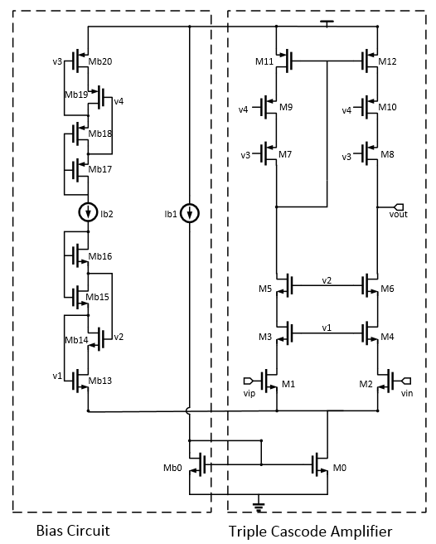

In order to save power, I used minimum size for the bias circuit. For Mb15, the size is $\frac{1}{3}$ x to make the effective size of Mb16 in series with Mb15 to be 4x. This is also true for Mb17 and Mb18 for PMOS. After simulation, I found v1 too high and v3 too low, which in turn compressed $v_{ds}$ for M1 and M2 and $v_{ds}$ for M11 and M12, so I made Mb13 and Mb20 slightly smaller. Finally, I found the gain not enough at the output, so I made the length for all transistors to be slightly larger, 360nM.